Body Composition and Cardiometabolic Health among South Asians: Distribution, Correlates, and Associations with Outcomes in the BELIEVE Cohort in Bangladesh.

Introduction
Cardiometabolic diseases, including type 2 diabetes mellitus, cardiovascular disease (CVD), and metabolic syndrome, are rising sharply among South Asians(1–3). South Asians experience a disproportionately high burden of cardiovascular disease at younger ages and at lower body mass index compared with other populations. This pattern is not adequately explained by traditional risk assessment models (4,5). Increasing cardio-metabolic risk among South Asians has been observed with the rising prevalence of obesity (6,7). The World Health Organization (WHO) defines Asian population BMI thresholds for public health action as 23 kg/m² for an increased risk and 27.5 kg/m² for a high risk (8). However, BMI does not accurately reflect visceral fat, which plays a crucial role in cardiovascular and metabolic risk (9–11). There is growing evidence to suggest that individuals with normal BMI (18.5–24.9 kg/m²) may still exhibit elevated percentage body fat, predisposing them to insulin resistance, dyslipidemia, and hypertension (12–14). This Normal Weight Obesity (NWO) phenotype is commonly seen in South Asian populations, with many remaining clinically undiagnosed due to their normal weight (15,16). In Bangladesh (Figure 1), this crisis is driven by the interaction of biological risks such as hypertension and metabolic dysfunction, behavioural factors like high salt, tobacco use, physical inactivity, and environmental factors like air pollution (17,18). These risks are amplified by rapid, unplanned urbanization, socioeconomic deprivation, and weak health infrastructure (19,20). These drivers, a significant lack of awareness about the condition, and a critical gap in screening mean we miss opportunities to focus the existing scarce resources in preventive efforts that identify individuals with high cardiovascular metabolic risk(21,22)
Accurate estimation of percentage fat with clear detection of visceral fat can be effective in identifying individuals at risk(19,23). This can be done using Magnetic Resonance Imaging (MRI), Computed Tomography (CT), or Dual-energy X-ray absorptiometry (DXA) scans, all of which are limited by cost, availability, and the expertise required in LMICs (24,25). Body composition provides information on fat mass, fat distribution, and lean mass, which is not captured by BMI (Figure 2) (26). Bioelectrical impedance analysis (BIA), which works by determining the electrical impedance of a small electrical current passing through the body, provides a relatively simple, inexpensive, and non-invasive method to estimate body composition in large populations (27,28). BIA-derived body fat measures are correlated with cardio-metabolic risk factors and outcomes in China, Israel, Colombia, and Scotland (29–32). BIA estimates are influenced by hydration status, recent food intake, physical temperature, ambient temperature, and ethnic differences (26,33). However, despite this, multiple validation studies show strong correlations between BIA estimates of fat mass and visceral fat with reference methods such as DXA and CT, supporting its use in epidemiological research in LMICs (34–36).
Despite its relevance, there is limited large-scale population-based evidence from South Asian LMICs describing bioimpedance-derived body composition and its relationship with cardio-metabolic disease. The BangladEsh Longitudinal Investigation of Emerging Vascular and Nonvascular Events (BELIEVE) cohort study (4) provides a unique opportunity to address this gap. BELIEVE is a large, household-based study of natives in Bangladesh across urban, urban-poor(slum), and rural settings with extensive epidemiological, behavioural, and clinical information recorded (Figure 3). This cohort enables detailed characterization of body composition measures across sociodemographic strata and prevalence of cardiometabolic diseases. It further allows us to examine associations between body composition, cardiometabolic diseases, multimorbidity, and lifestyle factors across diverse geographic and socioeconomic contexts.

The findings from this study will inform context-specific strategies to address biological, behavioural, environmental, and broader determinants of NCDs in South Asian populations.

Overall Aim
To provide a detailed account of the descriptive epidemiology of bioimpedance-derived body composition measures in South Asian populations in Bangladesh, including assessing relationships with the distribution and occurrence of cardiometabolic diseases using large-scale data from the BELIEVE cohort.

Research Objectives
- To describe the population distribution of bioimpedance-derived body composition measures and cardiometabolic diseases across age, sex, socioeconomic position, and urban, slum, and rural settings.
- To examine the cross-sectional associations between body composition measures and prevalent cardiometabolic diseases, including, type 2 diabetes, cardiovascular disease, hypertension, and multimorbidity
- To explore associations of body composition measures with incident type 2 diabetes during follow-up.

Methods

Study design and setting
This study will be based on data from the BELIEVE cohort. BELIEVE is a population-based prospective cohort study comprising 73,883 participants from 30,817 households established in Bangladesh between January 2016 and March 2020 across three contrasting settings: urban (Mirpur, Dhaka), urban poor or slum (Bauniabadh, Dhaka), and rural (Matlab, Chandpur) (4) shown in Figure 4.

Study population and follow-up
BELIEVE recruited individuals 1) aged 11 years or older, 2) who had lived in their household for at least three years, 3) intended to remain in the study area for at least five additional years, and 4) provided written informed consent. Participants were identified through complete household surveys and invited to attend local clinics for baseline assessment.
Participants in this study will include adults aged 18 years or older with available anthropometric and BIA measurements at baseline. Cardiometabolic diseases (CMDs) are clearly well-defined in adults, and BIA measurements are less influenced by growth and pubertal development (33,37). Before analysis, data completeness and internal consistency will be systematically assessed for all variables of interest. Predefined data quality checks will be applied to identify biologically implausible values using established thresholds. Complete case analysis will inform analytic sample sizes across study objectives.
Longitudinal analyses for incident cases will use available follow-up information focusing on type 2 diabetes, given its high burden, availability of supporting biomarkers, and ongoing outcome validation within the cohort. Individuals with type 2 diabetes at baseline will be excluded.

Exposures
Based on prior research, my primary independent variables are anthropometric and body composition measures. These include height, weight, BMI, waist circumference, hip circumference, waist-to-hip ratio, systolic and diastolic blood pressure, pulse, body fat mass, and body fat percentage derived from BIA (14,38). Derived indices will include fat mass index as a correlate for diabetes risk, visceral adiposity indicators as key correlates of hypertension and insulin resistance, total body water as a marker relevant to kidney disease and fluid balance, and phase angle as an indicator of hydration and cellular integrity (39).

Outcomes
The dependent variables are cardiometabolic diseases assessed at baseline and during follow-up. Prevalent outcomes include type 2 diabetes, cardiovascular disease, hypertension, and multimorbidity. These will be obtained from self-reported medical history supplemented by medication use and available clinical measurements as per cohort protocols (31). Cardiometabolic multimorbidity will be defined as the presence of two or more of these conditions (38) and will only be explored depending on the completeness of the outcomes in the dataset
Analysis of incident type 2 diabetes involves calculating time-to-event from baseline recruitment to the first reported diagnosis or censoring. Where available, glycated haemoglobin (HbA1c) will be used to assess concordance with self-reported diabetes and to explore patterns of undiagnosed disease at baseline.

Covariates and confounders
Covariates were selected based on prior evidence (38,40). These include continuous covariates such as age, systolic blood pressure (SBP) and diastolic blood pressure (DBP), glycated hemoglobin (HbA1c). Categorical covariates include sex, study site (urban, slum, or rural residence), education level, occupation status (employed vs non-employed), family income, marital status, smoking status, alcohol consumption frequency, psychosocial factors, and a family history of cardiometabolic diseases (yes vs no).

Data sources and measurement
Baseline data were collected using standardized protocols as detailed in the BELIEVE protocol. Anthropometry, blood pressure, and body composition were measured with calibrated instruments, and HbA1c and lipid measures were used to support validation and sensitivity analyses (4).

Statistical analysis
All statistical analyses will be conducted in R Version 4.5.1. The base R, “tidyverse” and “ggplot” packages will be used for statistical analysis and visualisation of results.

Assessment of normality
Normality for continuous variables will be assessed by visual inspection with histograms and Q-Q plots rather than the Shapiro-Wilk test or the Kolmogorov-Smirnov test, which are hypersensitive to small deviations in such large cohort sample sizes(41,42). Transformations will be applied where appropriate, or truncation will be used at the 1st and 99th percentiles.

Research aim 1
Descriptive statistics will summarise baseline anthropometric and BIA-derived body composition measures and the prevalence of cardiometabolic diseases. This will be across sex, age groups, socioeconomic position, and study sites. Age- and sex-standardised prevalence estimates will be reported. Prior studies have supported the examination of cross-sectional correlates of both body composition measures and disease prevalence (43). Continuous variables will be categorised into deciles to assess dose–response relationships without assuming linearity.
Continuous data will be reported as means with standard deviations (SD) or medians with interquartile ranges (IQR), and categorical variables will be presented as counts and percentages (29).

Research aim 2
Inferential analyses will primarily use regression-based approaches that allow adjustment for confounders, which is not possible with simple group comparison tests such as t-tests, Kruskal-Wallis, or chi-squares(44). In this study, both exposures (body composition measures) and cardiometabolic outcomes are expected to vary systematically by age, sex, socioeconomic position, and study site. Regression modelling will enable estimation of the independent associations of these covariates, which is key for valid inferences(45).
Multivariable linear regression will be used for continuous outcomes such as blood pressure, and multivariable logistic regression for binary outcomes, estimating β coefficients and odds ratios with 95% confidence intervals for prevalent type 2 diabetes, cardiovascular disease, hypertension, and multimorbidity. Models will be adjusted for relevant confounders (32,46) while preserving sample size: Model 1 will adjust for age, sex, and site; Model 2 will add socioeconomic variables; Model 3 will add behavioural factors.
Furthermore, to address the inherent dependency in household-based sampling, Linear Mixed-Effects Models (LMM) and Generalized Linear Mixed Models (GLMM) will be employed, incorporating household ID as a random effect(47). This accounts for the shared environmental and lifestyle exposures (e.g., diet and air pollution) unique to each household cluster. Regression models further allow flexible handling of non-normal data through transformations, categorisation (e.g. deciles), and non-linear terms, rather than reliance on rank-based tests (13,41).

Assumptions
Continuous variables are assumed to be approximately normal or transformable
Linear relationships are assumed for regression models, with non-linear terms or categorisation applied if assumptions are violated.
The likelihood ratio test will be used to compare models with and without body composition measures and goodness of fit assessed using the Akaike Information Criterion and adjusted R-squared. Differences in associations by sex, age group, socioeconomic status, and study setting will be explored by stratified analyses and inclusion of interaction terms as relevant in multivariable regression models. I will build skills to do this in my advanced biostatistics module.

Research aim 3
Cox proportional hazard regression models will examine associations between baseline body composition measures and incident type 2 diabetes. Dose–response relationships will be evaluated using continuous and categorised exposures. These analyses will be interpreted cautiously due to preliminary outcomes being self-reported while incident outcome validation is ongoing.

Assumptions
Baseline body composition is assumed to precede incident outcomes
There are constant hazard ratios over time
Censoring is assumed to be non-informative
Sensitivity analyses excluding those on medication and with cardiometabolic diseases at baseline will be performed.

Handling of missing data
Missing data will be handled according to a recommended framework for observational studies (48). Patterns and extent of missingness will be examined and visualised using the “md.pattern” function in the “mice” package. Missing data patterns will be assessed across age, sex, and study site to evaluate whether missingness is random or systematic. Previous BELIEVE protocol analyses report very low missingness for alcohol, tobacco, BMI, and waist-to-hip ratio (<0.05%).
Missing data will initially be handled using complete case analysis (CCA) in exploratory analyses to assess patterns of missingness and potential impact on the estimate (49). If missingness is substantial and compatible with a missing at random (MAR) assumption multiple imputation will be considered.
Directed acyclic graphs will guide variable selections and evaluate whether the assumptions required for multiple imputation are appropriate. Predictive mean matching will be applied for continuous variables, logistic regression for binary variables, and multinomial logistic regression for categorical variables (50).
I expect to develop a clearer strategy after looking at the data and further self-study of using R for this task

Bias and limitations
Potential biases include misclassification of self-reported disease, residual confounding, and measurement error in BIA estimates due to hydration status.
Reverse causality in cross-sectional analyses will be acknowledged.

Discussion
This study aims to investigate body composition patterns and their cardiometabolic correlates across diverse urban, slum, and rural populations in Bangladesh using the BELIEVE cohort. The strengths of the study include: 1) a large prospective population-based sample with a range of socioeconomic, psychosocial, behavioural, and biological variables to be examined and alongside standardized anthropometric and bioelectrical impedance measurements in a South Asian LMIC setting where such data are scarce, 2) The cohort enables detailed characterization of body composition beyond BMI and allows examination of multimorbidity, and early disease onset across demographic strata, 3) Self-reported CMDs can be validated through medical records and biological markers. 4) The prospective design allows analyses of incident type 2 diabetes allowing temporal interpretation.
However, there are limitations to consider. 1) Bioelectrical impedance estimates are sensitive to hydration status, recent food intake, and physical activity. 2) Prediction equations for body composition may require further validation in South Asian populations. 3) Some outcomes are still undergoing validation, limiting the scope of longitudinal analyses. 4) Misclassification may occur due to undiagnosed diabetes or episodic blood pressure elevation, 5) the cohort involved voluntary participation of invited households hence is not nationally representative, however, its internal heterogeneity supports generalisability to similar settings and 6) Reverse causality limits causal inference for cross-sectional associations.
Overall, the value of this study lies in its novel contribution to understanding multidimensional determinants to cardiometabolic risk in an understudied South Asian LMIC population, informing more accurate risk stratification and context-specific prevention strategies.

Risk assessment and contingency plans
Potential risks during the development of the study have been identified, and contingency plans have been made (Table 1).
Table 1. Risk and contingency plans
Risk | Likelihood | Severity | Contingency plan
Accessing the dataset due to the ongoing nature of the cohort | High | Medium | I have worked with my supervisor to fill in the data request sheet. However, I acknowledge that this is going to be updated because validation is ongoing and may influence my variables.
Insufficient knowledge to conduct appropriate statistical tests and data analysis | Low | Medium | Most of my intended statistical analysis techniques will be covered in the Advanced Biostatistics for Epidemiology module later in the term. I will also be frequently checking with my supervisor, who is a statistician on my statistical methods.
Coding or software competency | Low | High | I am self-studying on how to handle, clean large datasets with R.  I have created a Git repository for my dissertation project and will ensure that code and other essential documents will always be backed.
Data may not be sufficient to conduct the intended incident analysis | Low-medium | High | I have scheduled regular meetings with my supervisor to discuss data feasibility and adjustment of my research question
Personal emergencies or illness | Low | Low | I am accounted for additional time for my dissertation as reflected in my Gantt chart

Timeline
To allow for better visualization of the timeline of the dissertation, a Gantt chart has been created below 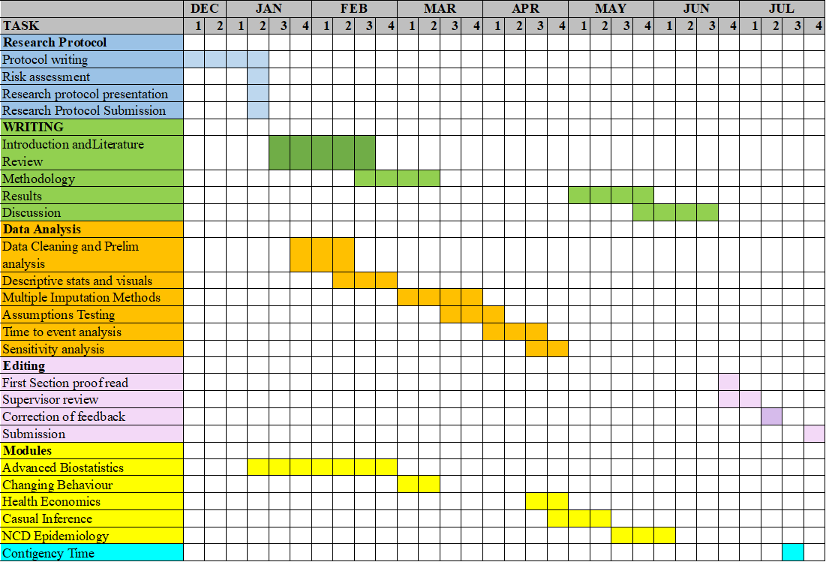

Appendix
Figure 1: Multidimensional drivers of cardiometablic disease in Bangladesh

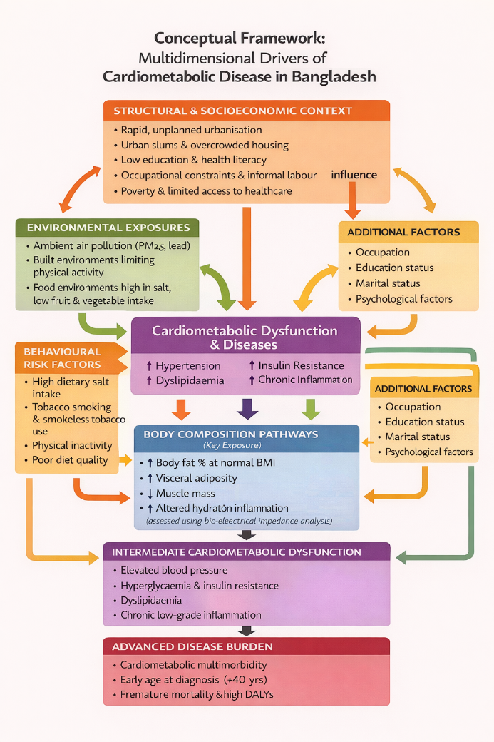
Source: xxx

Figure 2: Body composition measures using BIA
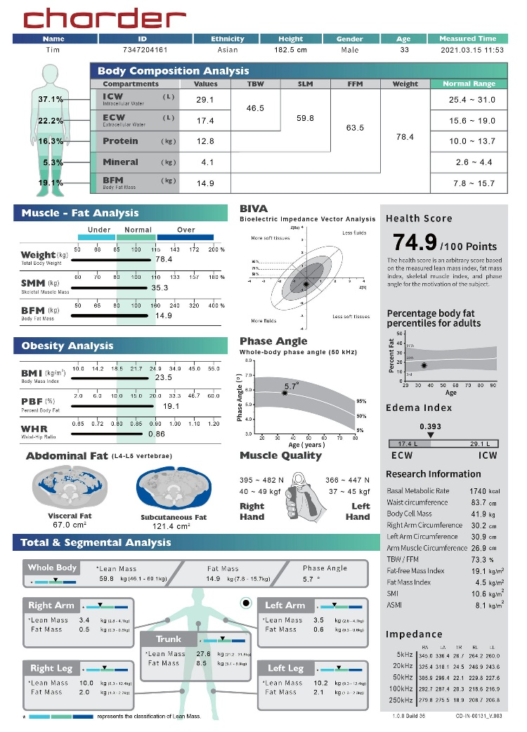
Figure 3: BELIEVE Study design and procedures
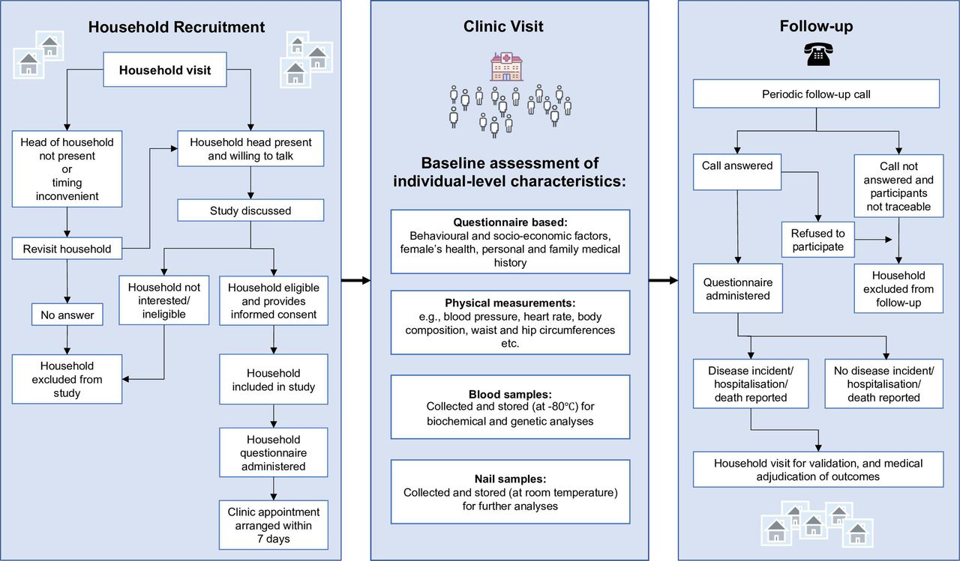
Figure 4: Location of the BELIEVE study sites.
